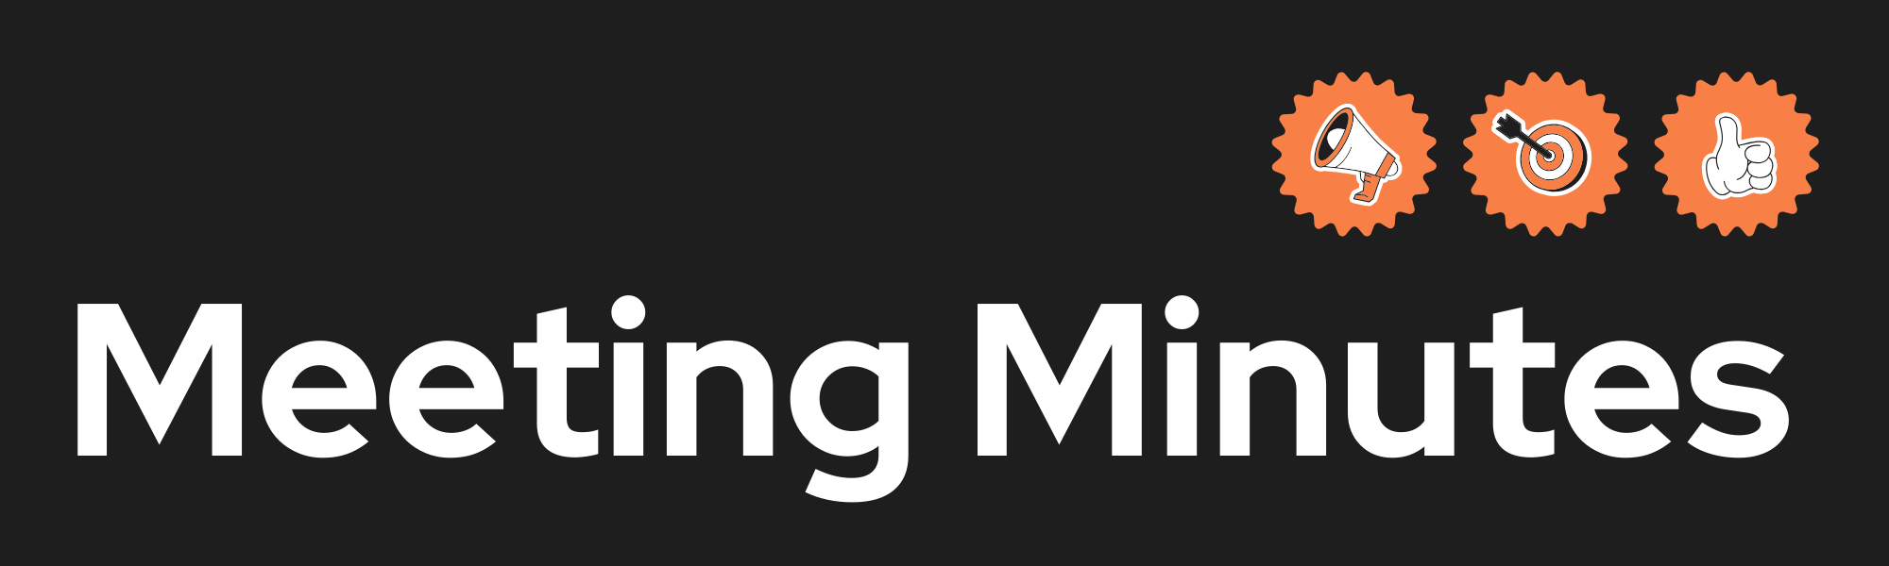
Date and Time
Project Name
Meeting Goal | Prepare sprint 1
Facilitator
Note taker
Attendees
Roundtable Updates (each group member to contribute)
Discussion points | - Application topic clear?  - Code of conduct agreed?  - Github repo created with correct branches, and all team members added?  - Github project created and all team members added?  - Discuss personas  - Discuss ethical issues  - Way forward for preparing final submission
Actions (list tasks and assign a group member)

